1.Develop a Java program that prints all real solutions to the quadratic equation  
ax2+bx+c = 0. Read in a, b, c and use the quadratic formula. If the  
discriminate b2  
-4ac is negative, display a message stating that there are no  
real solutions.

SOURCE CODE

import java.util.Scanner;

public class quadratic

{

public static void main(String args[])

{

Scanner input=new Scanner(System.in);

System.out.print("enter the value of a:");

double a=input.nextDouble();

System.out.print("enter the value of b:");

double b=input.nextDouble();

System.out.print("enter the value of c:");

double c=input.nextDouble();

double d=b*b-4*a*c;

if(d>0)

{

double r1=(-b+Math.pow(d,0.5))/(2.0*a);

double r2=(-b-Math.pow(d,0.5))/(2.0*a);

System.out.println("the roots are real and distinct r1="+r1+"and r2="+r2);

}

else if(d==0.0)

{

double r1=-b/(2.0*a);

System.out.println("the roots are real and equal r1=r2="+r1);

}

else

{

double r1=-b/(2*a);

double r2=Math.sqrt(-d) / (2 * a);

System.out.println("roots are not real");

System.out.println("r1="+r1+"+i"+r2+" and r2="+r1+"-i"+r2);

}

}

}

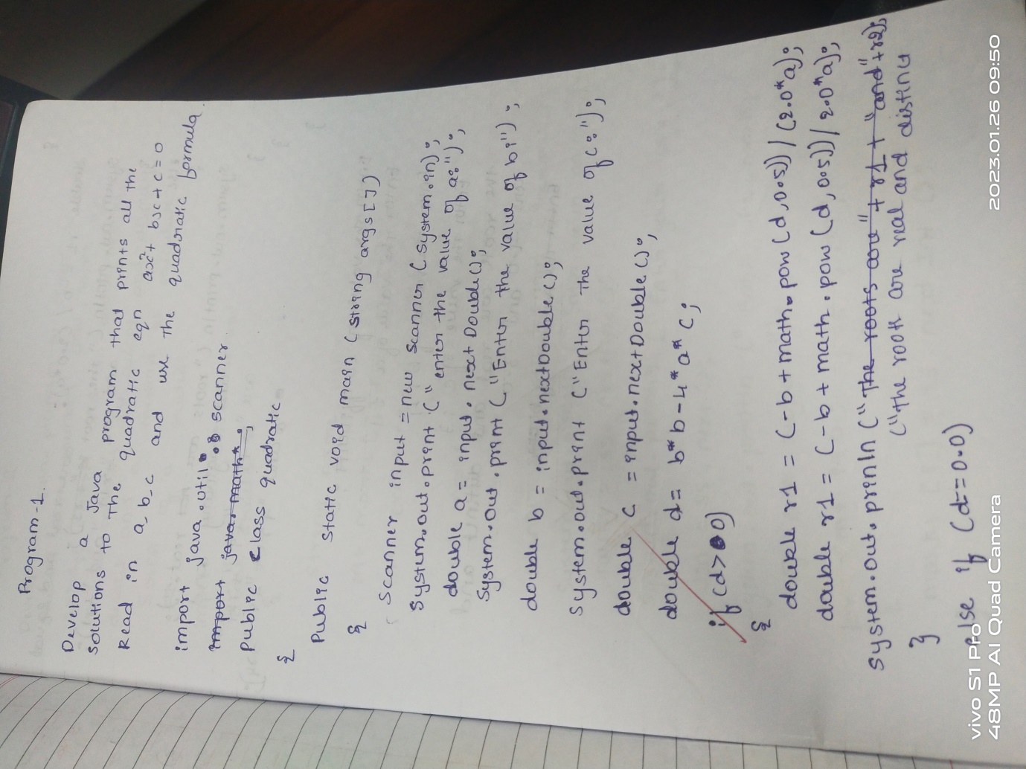

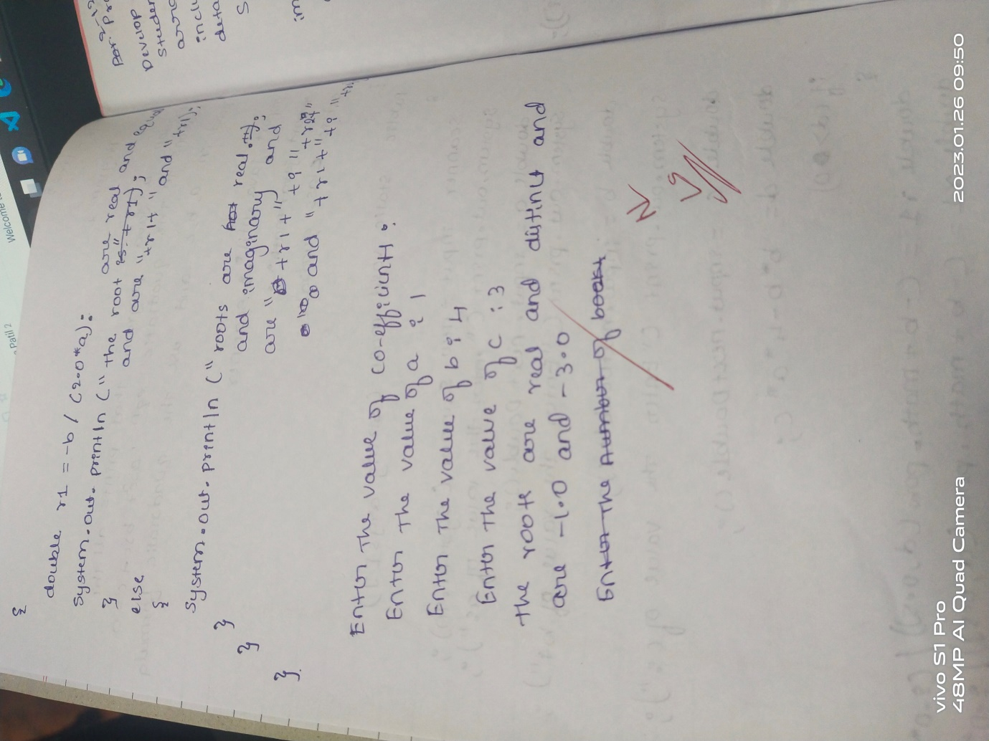

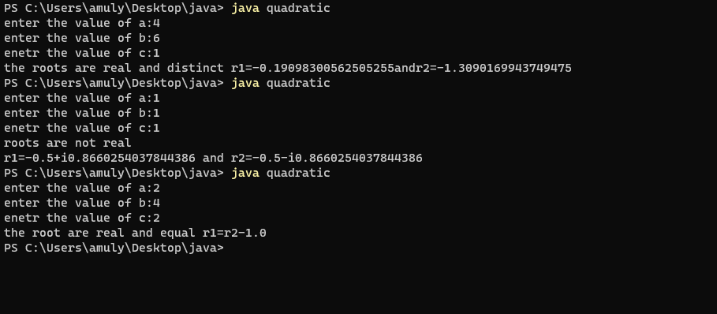

2. Develop a Java program to create a class Student with members usn, name an array credits and an array marks. Include methods to accept and displaydetails and a method to calculate SGPA of a student. . Develop a Java program to create a class Student with members usn, name,  
an array credits and an array marks. Include methods to accept and display  
details and a method to calculate SGPA of a student.

import java.util.Scanner;

class Student

{

String name,usn;

int marks[]=new int[5];

int credits[]=new int[5];

void input(){

Scanner ss=new Scanner(System.in);

System.out.println("enter your name:");

name=ss.nextLine();

System.out.println("enter your usn:");

usn=ss.next();

System.out.println("enter the marks of each subject:");

for(int i=0;i<5;i++)

{

marks[i]=ss.nextInt();

}

System.out.println("enter the number of credits for each subject:");

for(int i=0;i<5;i++)

credits[i]=ss.nextInt();

}

void display(){

System.out.println("NAME:"+name);

System.out.println("USN:"+usn);

for(int i=0;i<5;i++)

{

System.out.println("marks of each subject"+(i+1)+"="+marks[i]);

System.out.println("number of credits for each subject"+(i+1)+"="+credits[i]);}

}

void calc()

{

int gr_point[]=new int[5];

int sgpa=0;

int sum=0;float res;

for(int i=0;i<5;i++)

{

if(marks[i]>=90)

gr_point[i]=10;

else if(marks[i]>=80)

gr_point[i]=9;

else if(marks[i]>=70)

gr_point[i]=8;

else if(marks[i]>=60)

gr_point[i]=7;

else if(marks[i]>=50)

gr_point[i]=6;

else if(marks[i]>=40)

gr_point[i]=5;

else if(marks[i]>=35)

gr_point[i]=4;

else if(marks[i]<35 && marks[i]>0)

gr_point[i]=0;

else

System.out.println("invalid marks for subject"+(i+1)+"entered try agian");

sgpa+=(gr_point[i]*credits[i]);

sum+=(credits[i]);

}

res=(float)sgpa/sum;

System.out.println("SGPA="+res);

}

public static void main(String xx[])

{

Student s1=new Student();

s1.input();

s1.display();

s1.calc();

}

}

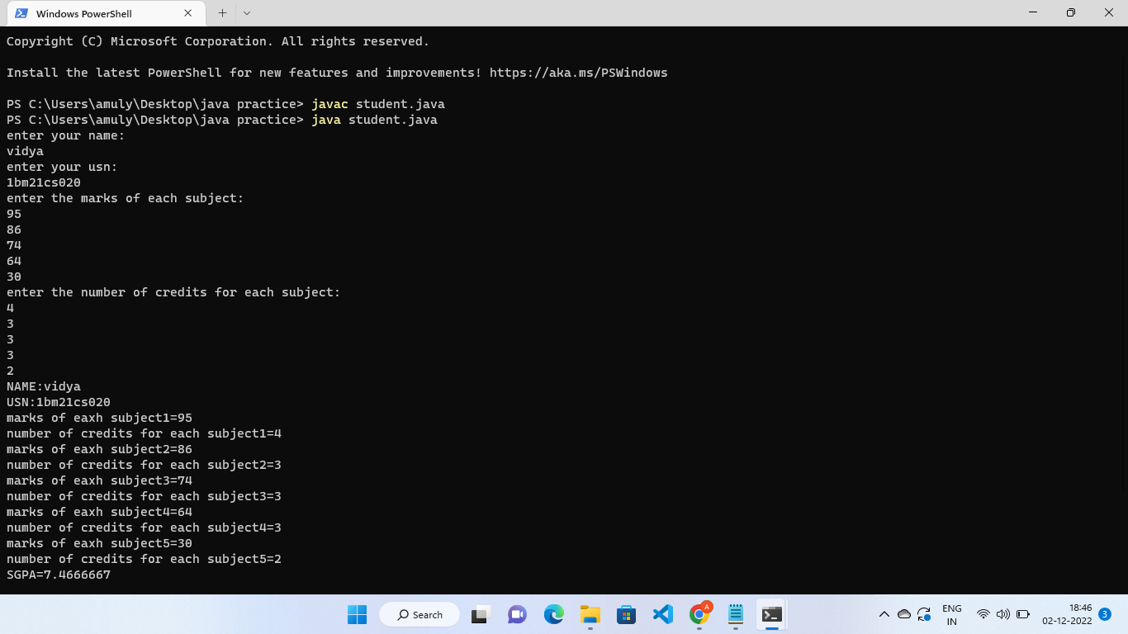

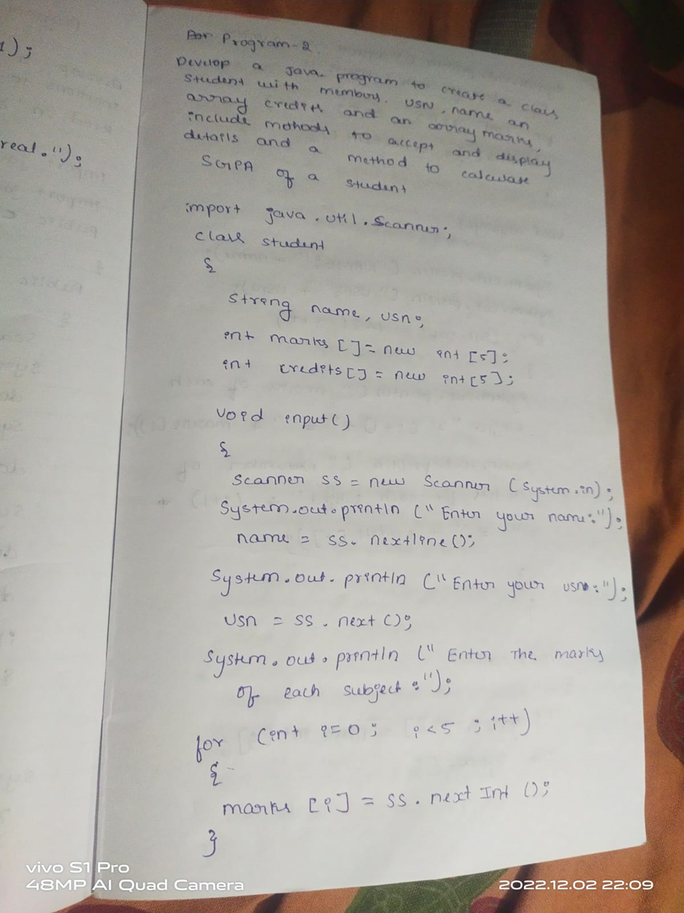

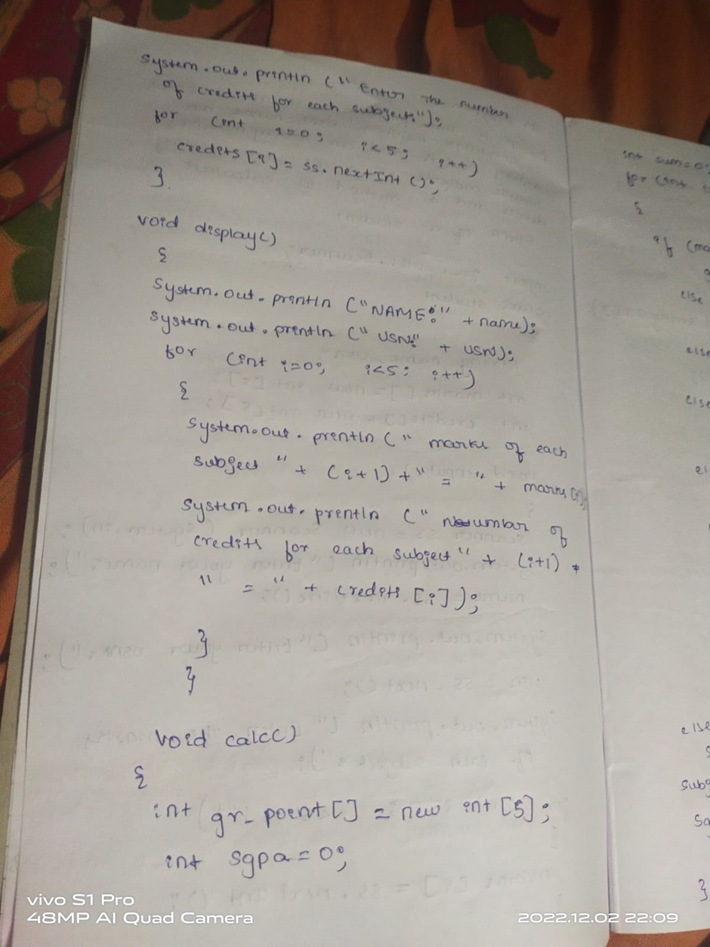

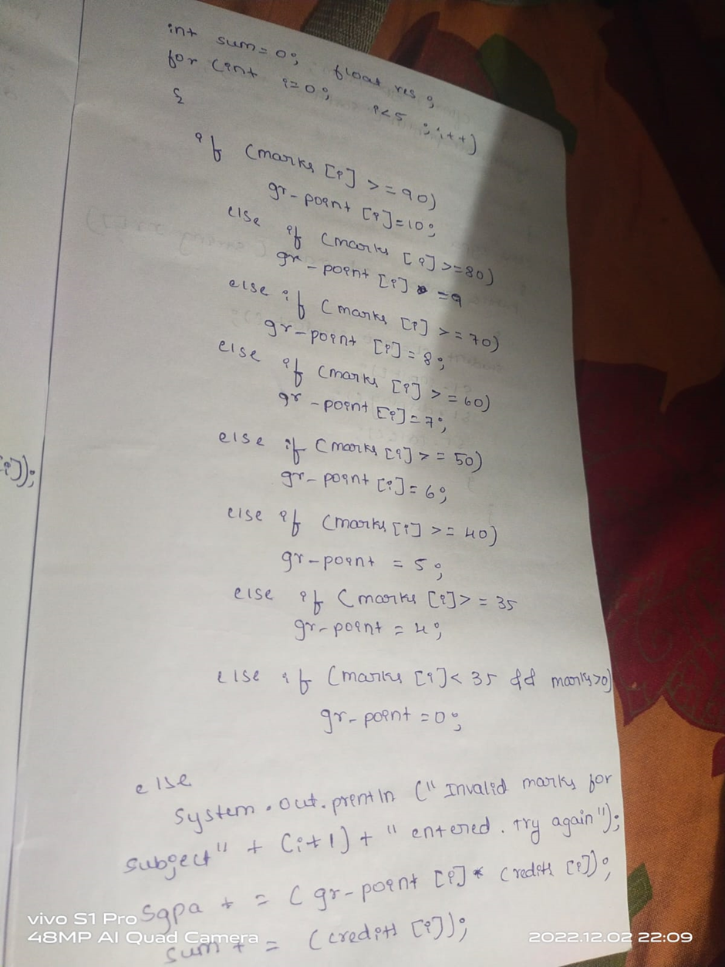

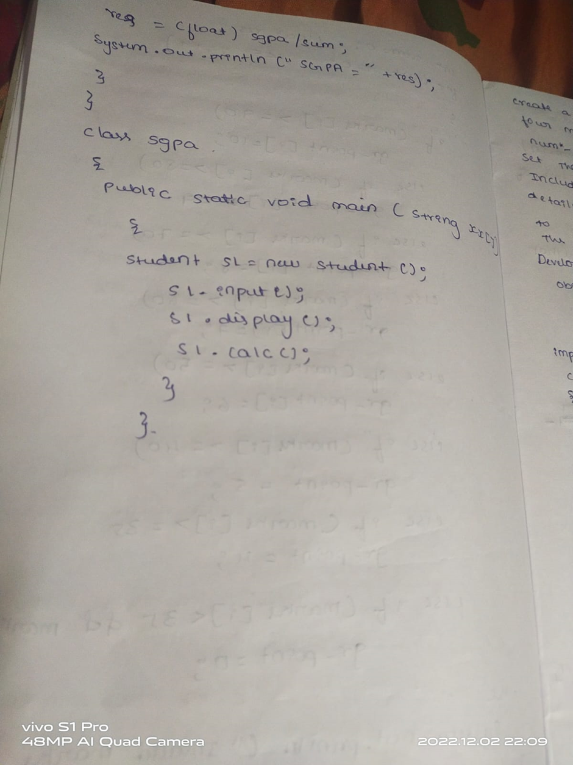

3.Create a class Book which contains four members: name, author, price,  
num_pages. Include a constructor to set the values for the members. Include  
methods to set and get the details of the objects. Include a toString( ) method  
that could display the complete details of the book. Develop a Java program  
to create n book objects.

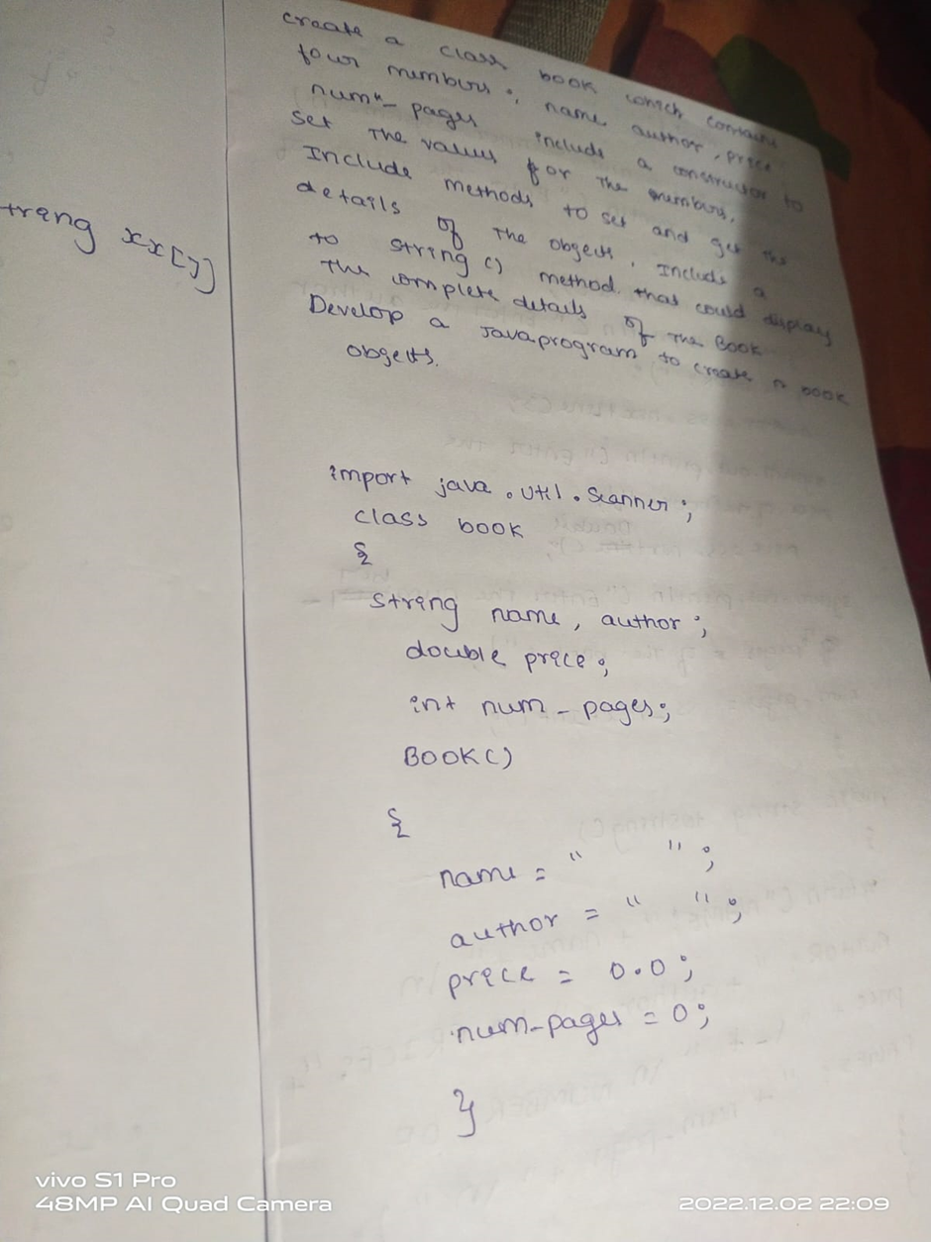

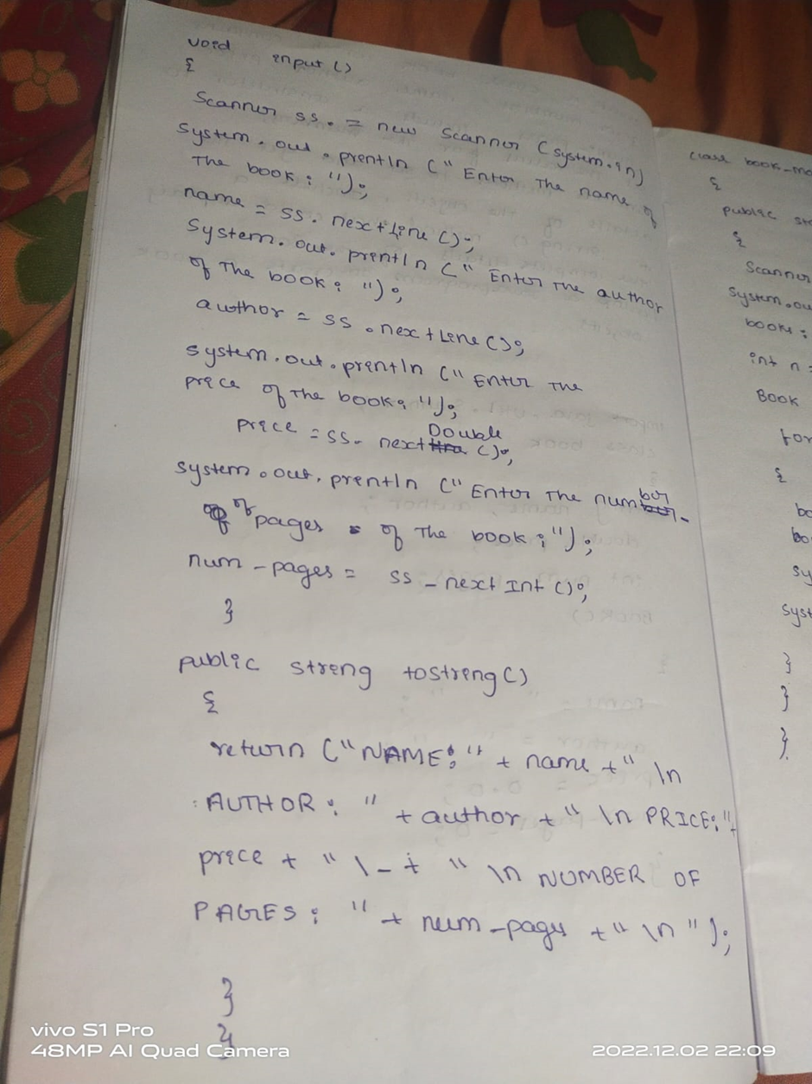

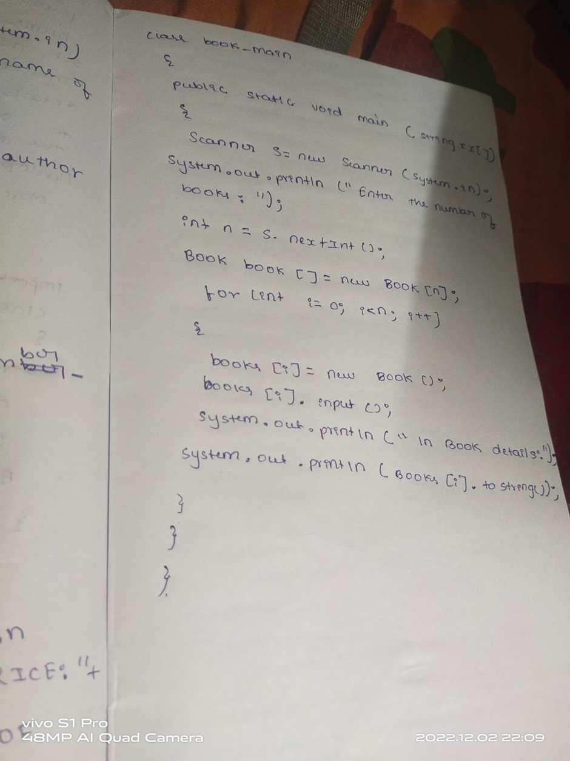

import java.util.Scanner;

class Book

{

String name,author;

double price;

int num_pages;

void Book()

{

name=" ";

author=" ";

price=0.0;

num_pages=0;

}

void input()

{

Scanner ss= new Scanner(System.in);

System.out.println("Enter the name of the book:");

name=ss.nextLine();

System.out.println("Enter the author of the book:");

author=ss.nextLine();

System.out.println("Enter the number of pages of the book:");

num_pages=ss.nextInt();

System.out.println("Enter the price of the book:");

price=ss.nextDouble();

}

public String toString()

{

return("NAME:"+name+"\nAUTHOR:"+author+"\nPRICE:"+price+"/-"+"\nNUMBER OF PAGES:"+num_pages +"\n") ;

}

public static void main(String args[])

{

Scanner s=new Scanner(System.in);

System.out.println("Enter the number of books:");

int n=s.nextInt();

Book book[]=new Book[n];

for(int i=0;i<n;i++)

{

book[i]=new Book();

book[i].input();

System.out.println("\n Book details:");

System.out.println(book[i]);

}

}

}

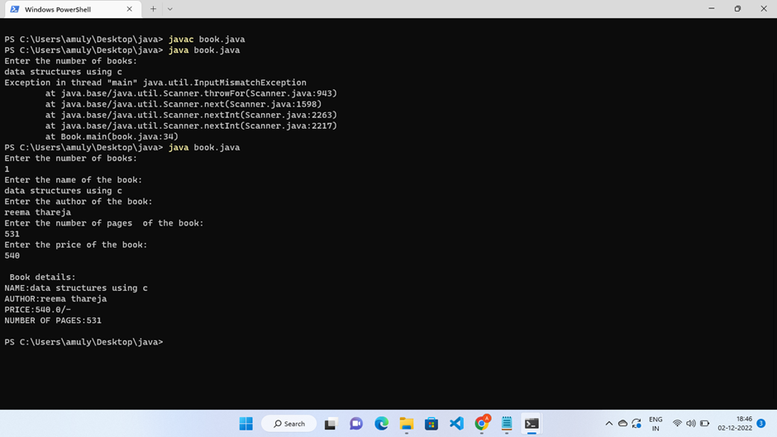

4.Develop a Java program to create an abstract class named Shape  
that contains two integers and an empty method named printArea( ). Provide  
three classes named Rectangle, Triangle and Circle such that each one of the  
classes extends the class Shape. Each one of the classes contain only the  
method printArea( ) that prints the area of the given shape.

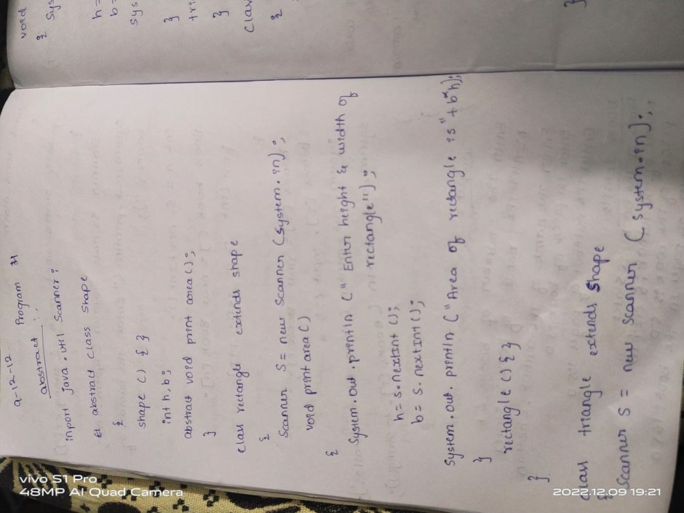

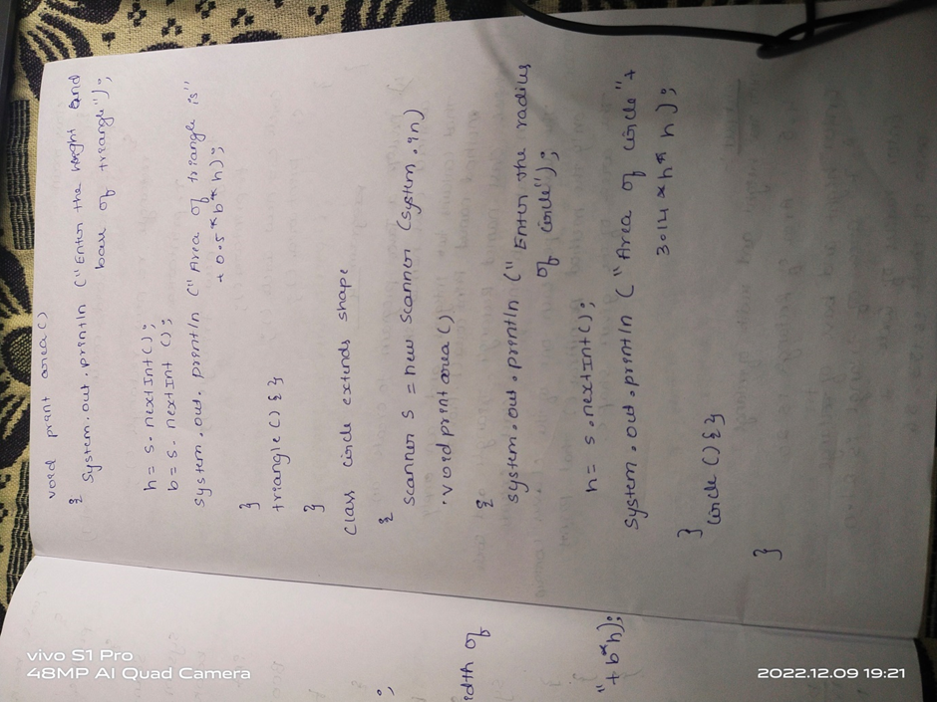

import java.util.*;

abstract class shape

{

int x,y;

abstract void area(double x,double y);

}

class Rectangle extends shape

{

void area(double x,double y)

{

System.out.println("Area of rectangle is :"+(x*y));

}

}

class Circle extends shape

{

void area(double x,double y)

{

System.out.println("Area of circle is :"+(3.14*x*x));

}

}

class Triangle extends shape

{

void area(double x,double y)

{

System.out.println("Area of triangle is :"+(0.5*x*y));

}

}

public class AbstactDDemo

{

public static void main(String[] args)

{

Rectangle r=new Rectangle();

r.area(2,5);

Circle c=new Circle();

c.area(5,5);

Triangle t=new Triangle();

t.area(2,5);

}

}

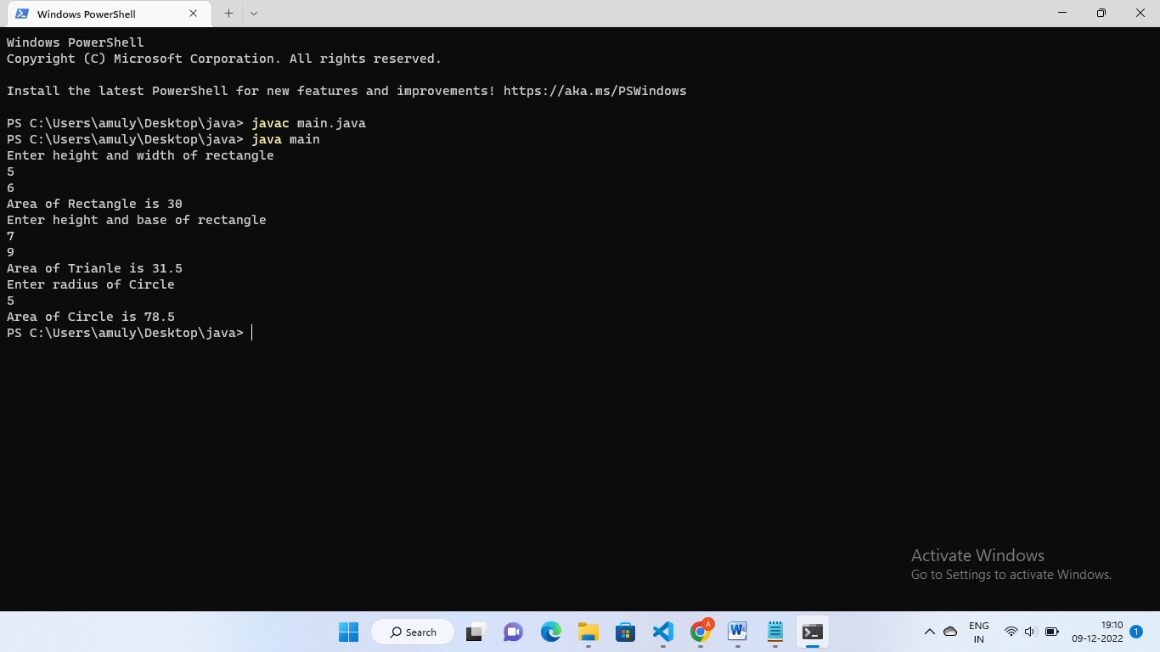

5. Develop  
a Java program to create a class Bank that maintains two kinds of account for  
its customers, one called savings account and the other current account. The  
savings account provides compound interest and withdrawal facilities but no  
cheque book facility. The current account provides cheque book facility but  
no interest. Current account holders should also maintain a minimum balance  
and if the balance falls below this level, a service charge is imposed.  
  
Create a class Account that stores customer name, account number  
and type of account. From this derive the classes Cur-acct and Sav-acct to  
make them more specific to their requirements. Include the necessary methods  
in order to achieve the following tasks:  
  
a)     Accept deposit from customer and update the  
balance.  
  
b)     Display the balance.  
  
c)     Compute and deposit interest  
  
d)     Permit withdrawal and update the balance  
  
Check for the minimum balance, impose penalty if necessary and  
update the balance.  
  
Complete the observation and execution of both the above programs tomorrow.

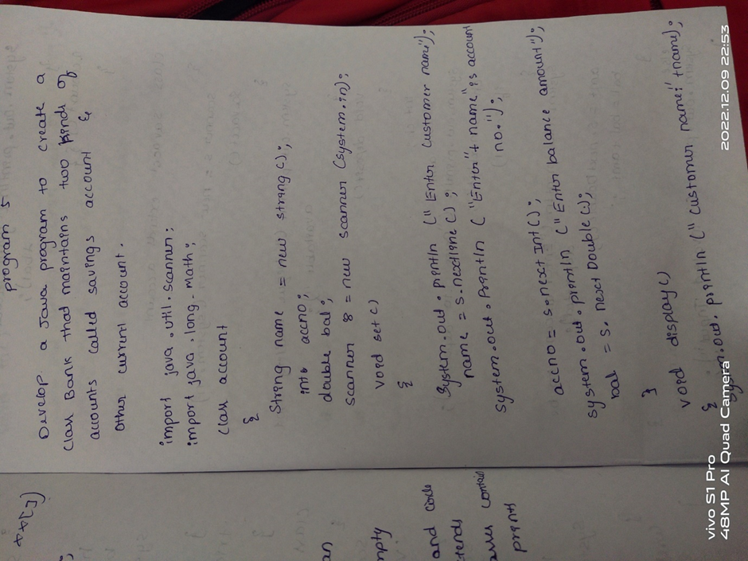

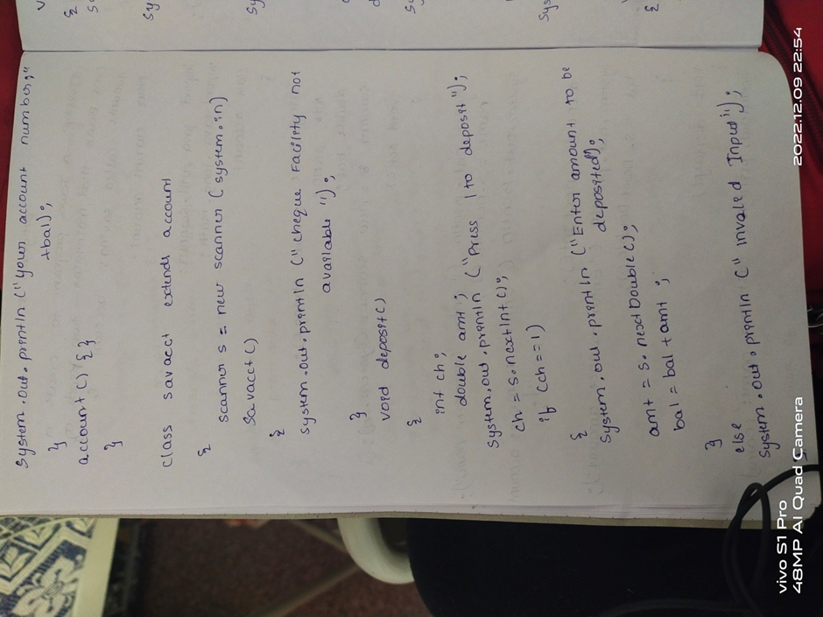

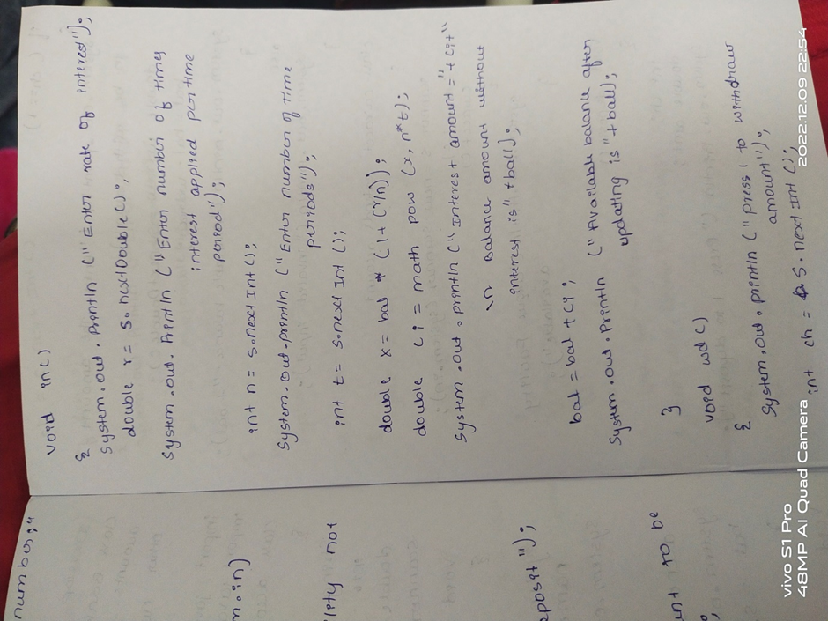

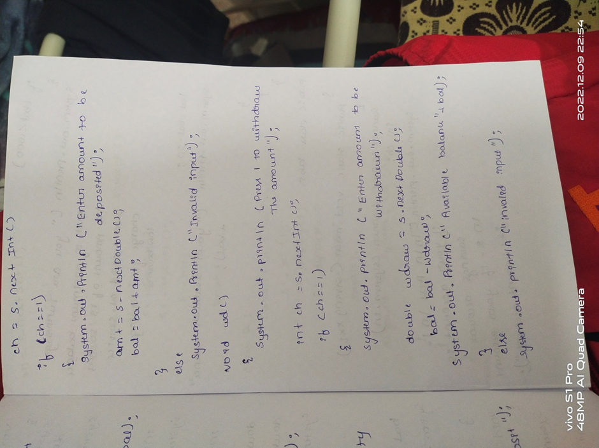

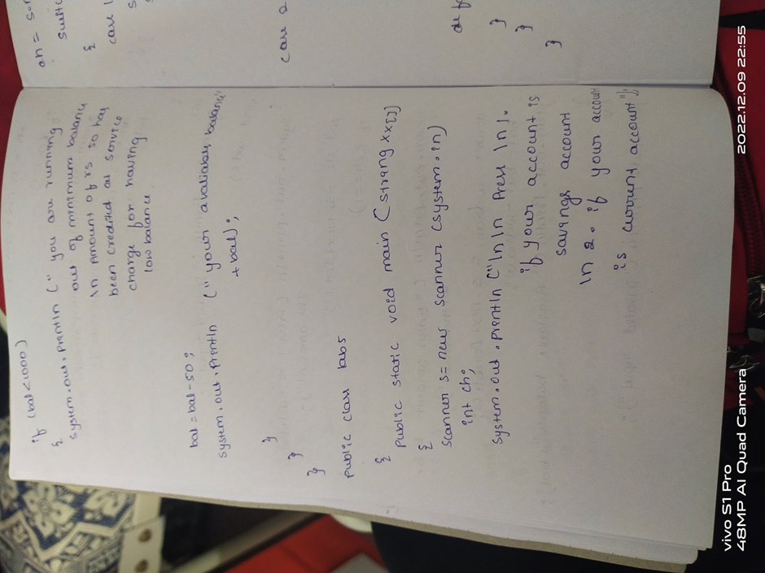

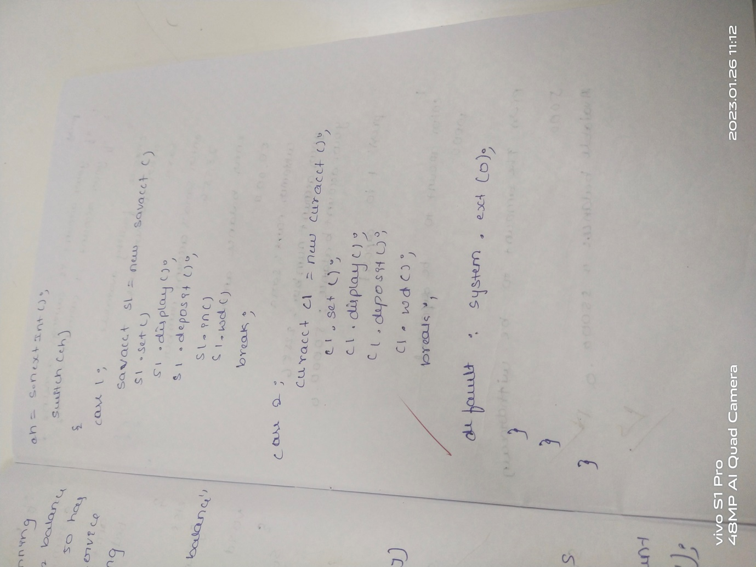

import java.util.Scanner;

import java.lang.Math;

class account

{

String name=new String();

int accno;

double bal;

Scanner s=new Scanner(System.in);

void set()

{

System.out.println("Enter customer name");

name=s.nextLine();

System.out.println("Enter "+name+"'s account number");

accno=s.nextInt();

System.out.println("Enter balance amount ");

bal=s.nextDouble();

}

void display()

{

System.out.println("Customer Name:"+name);

System.out.println("Your account number:"+accno);

System.out.println("Your Account Balance:"+bal);

}

}

class savacct extends account

{

Scanner s=new Scanner(System.in);

savacct()

{

System.out.println("Cheque Facility not available ");

}

void deposit()

{

int ch;

double amt;

System.out.println("Press 1 to deposit ");

ch=s.nextInt();

if(ch==1)

{

System.out.println("Enter amount to be deposited ");

amt=s.nextDouble();

bal=bal+amt;

}

else

System.out.println("Invalid Input");

}

void in()

{

System.out.println("Enter rate of interest ");

double r=s.nextDouble();

System.out.println("Enter number of times interest applied per time period");

int n=s.nextInt();

System.out.println("Enter number of time periods");

int t=s.nextInt();

double x=bal*(1+(r/n));

double ci=Math.pow(x,n*t);

System.out.println("Interest amount="+ci+" \nBalance amount without interest is"+bal);

bal=bal+ci;

System.out.println("Available balance after updating is"+bal);

}

void wd()

{

System.out.println("Press 1 to withdraw ammount");

int ch=s.nextInt();

if(ch==1)

{

System.out.println("Enter the amount to be withdrawn ");

double wdraw=s.nextDouble();

bal=bal-wdraw;

System.out.println("Available Balance:"+bal);}

else System.out.println("Invalid input");

}

}

class curacct extends account

{

Scanner s=new Scanner(System.in);

curacct()

{

System.out.println("Cheque Facility available ");

}

void deposit()

{

int ch;

double amt;

System.out.println("Press 1 to deposit ");

ch=s.nextInt();

if(ch==1)

{

System.out.println("Enter amount to be deposited ");

amt=s.nextDouble();

bal=bal+amt;

}

else

System.out.println("Invalid Input");

}

void wd()

{

System.out.println("Press 1 to withdraw ammount");

int ch=s.nextInt();

if(ch==1)

{

System.out.println("Enter the amount to be withdrawn ");

double wdraw=s.nextDouble();

bal=bal-wdraw;

System.out.println("Available Balance:"+bal);}

else System.out.println("Invalid input");

if(bal<1000)

{

System.out.println("You are running out of minimum balance \nAmount of rs 50 has been credited as service charge for having low balance");

bal=bal-50;

System.out.println("Your Available Balance:"+bal);

}

}

}

public class Lab5

{

public static void main(String args[])

{

Scanner s=new Scanner(System.in);

int ch;

System.out.println("\n\nPress\n1. if your account is savings account \n2. if your account is current account");

ch=s.nextInt();

switch(ch)

{

case 1:

savacct s1=new savacct();

s1.set();

s1.display();

s1.deposit();

s1.in();

s1.wd();

break;

case 2:

curacct c1=new curacct();

c1.set();

c1.display();

c1.deposit();

c1.wd();

break;

default : System.exit(0);

}

}

}

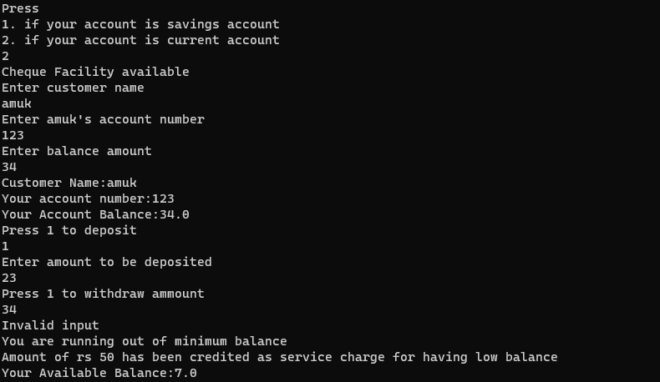

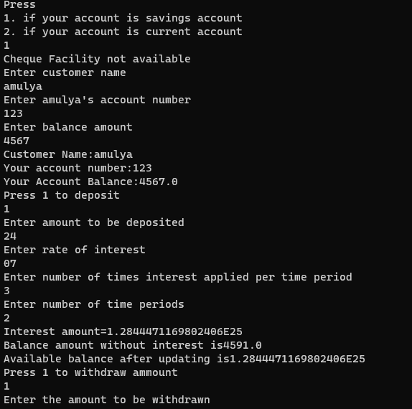

6.Write

a program that demonstrates handling of exceptions in inheritance tree. Create

a base class called “Father” and derived class called “Son” which extends the

base class. In Father class, implement a constructor which takes the age and

throws the exception WrongAge( ) when the input age<0. In Son class, implement

a constructor that cases both father and son’s age and throws an exception if

son’s age is >=father’s age.

import java.util.*;

class fatherAgeException extends Exception

{

public String toString(){

return("Father's age is less that 0");

}

}

class sonAgeException extends Exception{

int a;

sonAgeException(int age){

a=age;

}

public String toString(){

if(a<0)

return("Son's age is less than 0");

else

return("Son's age is more than father's age");

}

}

class Father{

int age;

Scanner in=new Scanner(System.in);

Father(){

System.out.println("Enter the father's age: ");

age=in.nextInt();

}

void ex1() throws fatherAgeException

{

if(age<0)

throw new fatherAgeException();

}

}

class Son extends Father{

int age;

Son(){

System.out.println("Enter the age of son: ");

age=in.nextInt();

}

void ex2() throws sonAgeException{

if(age<0||age>super.age){

throw new sonAgeException(age);

}

}

}

public class except {

public static void main(String[] args){

Son s=new Son();

try{

s.ex1();

}

catch(fatherAgeException e){

System.out.println(e);

}

try{

s.ex2();

}

catch(sonAgeException e){

System.out.println(e);

}

}

}

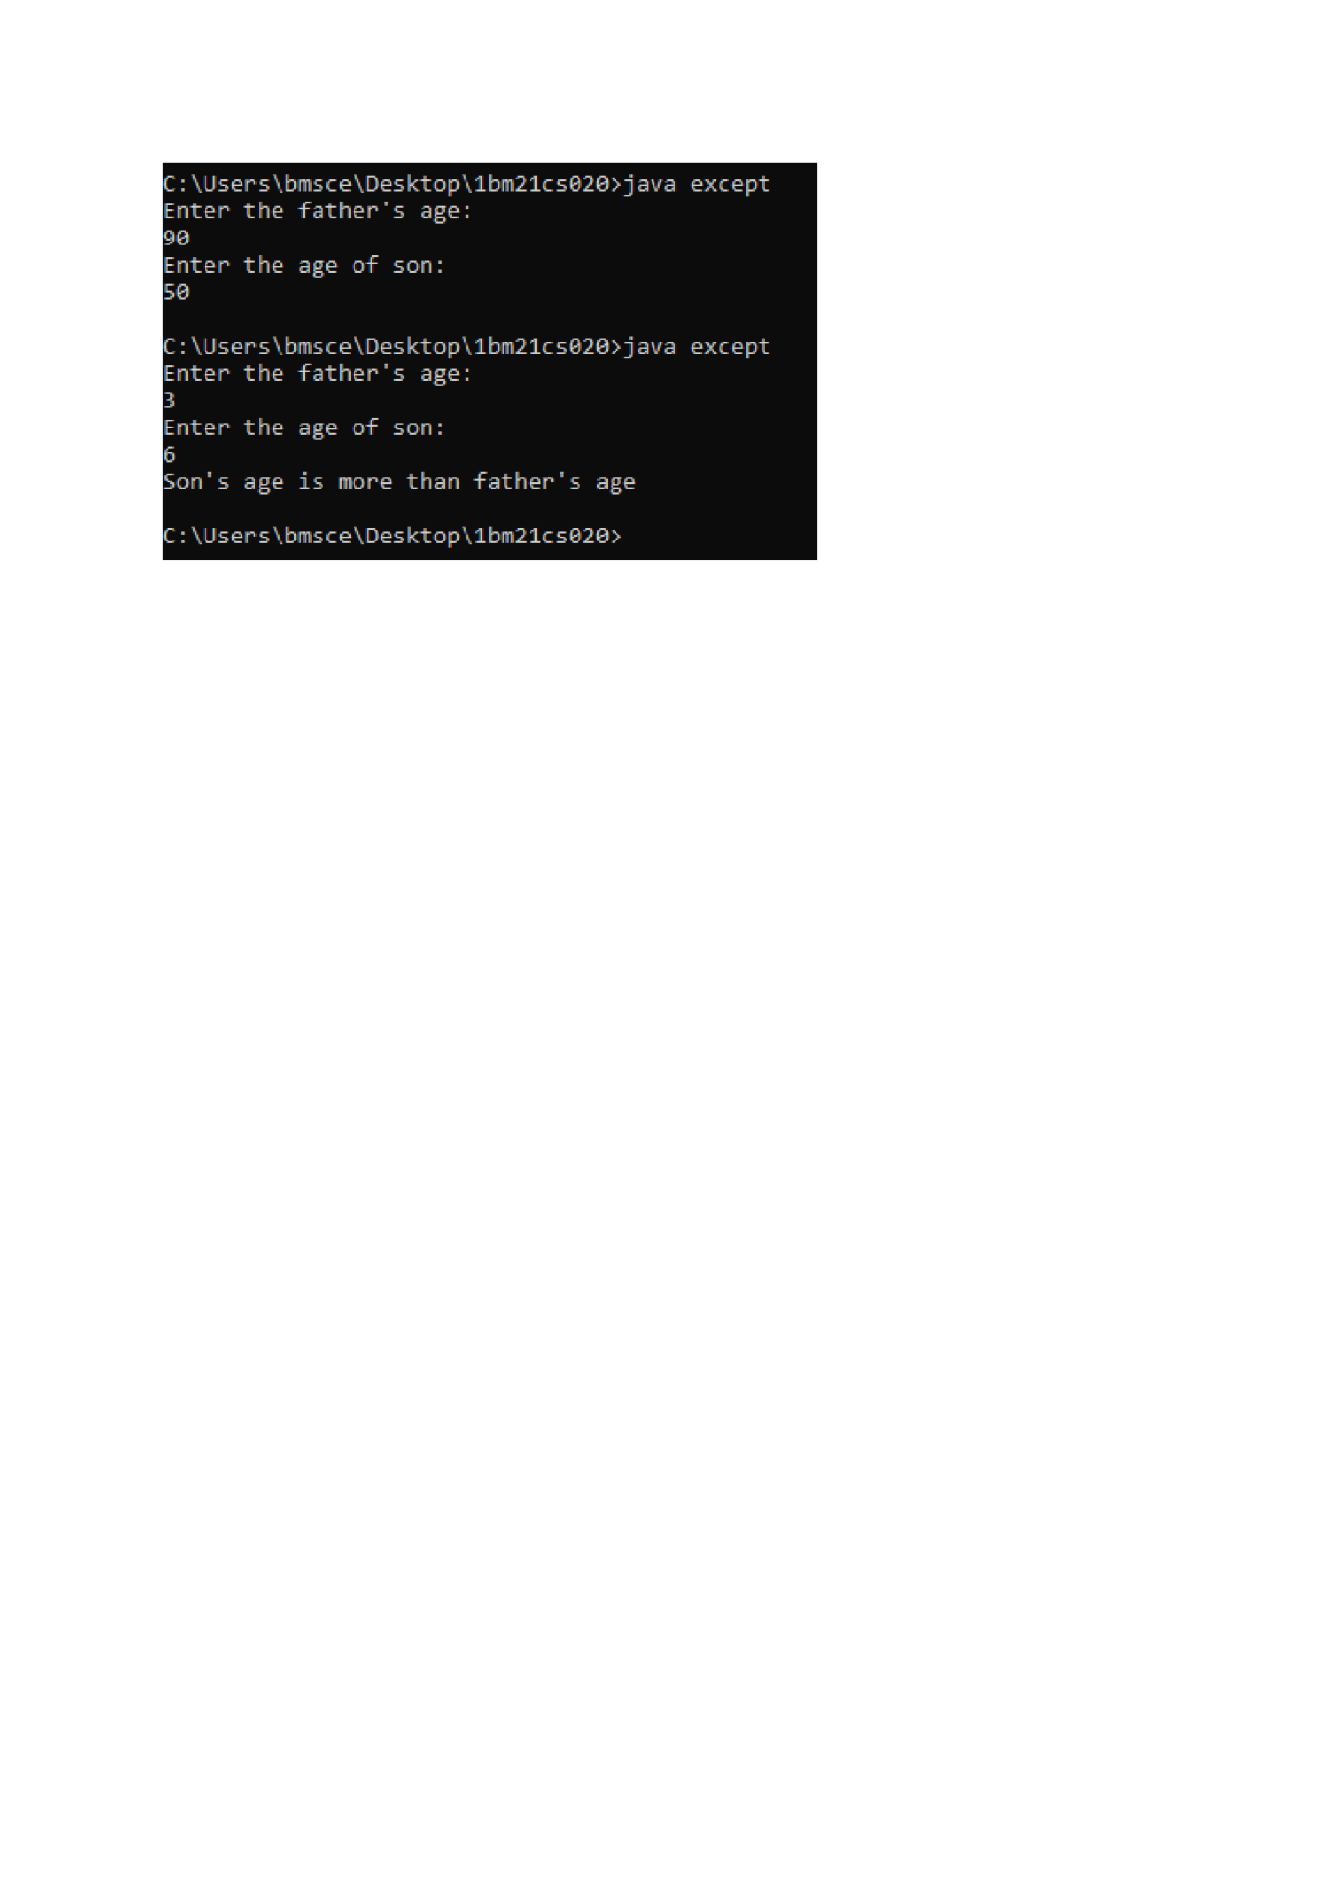

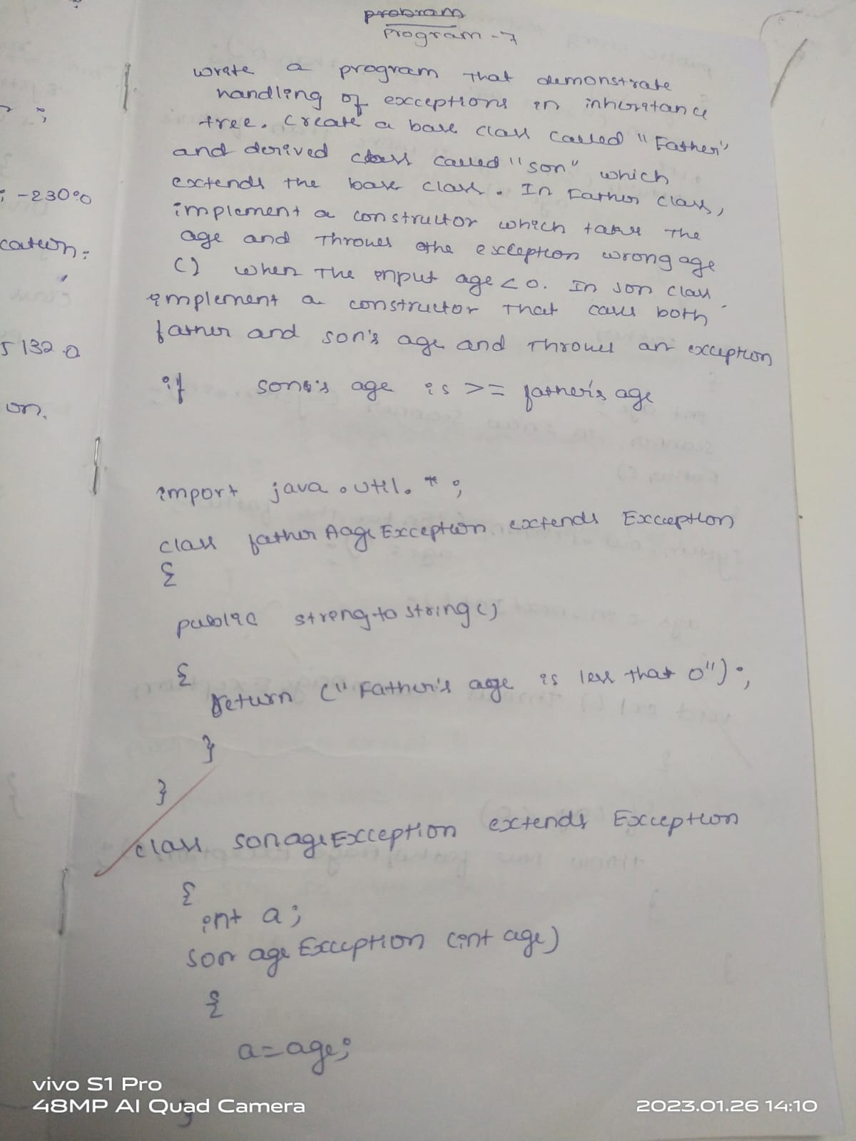

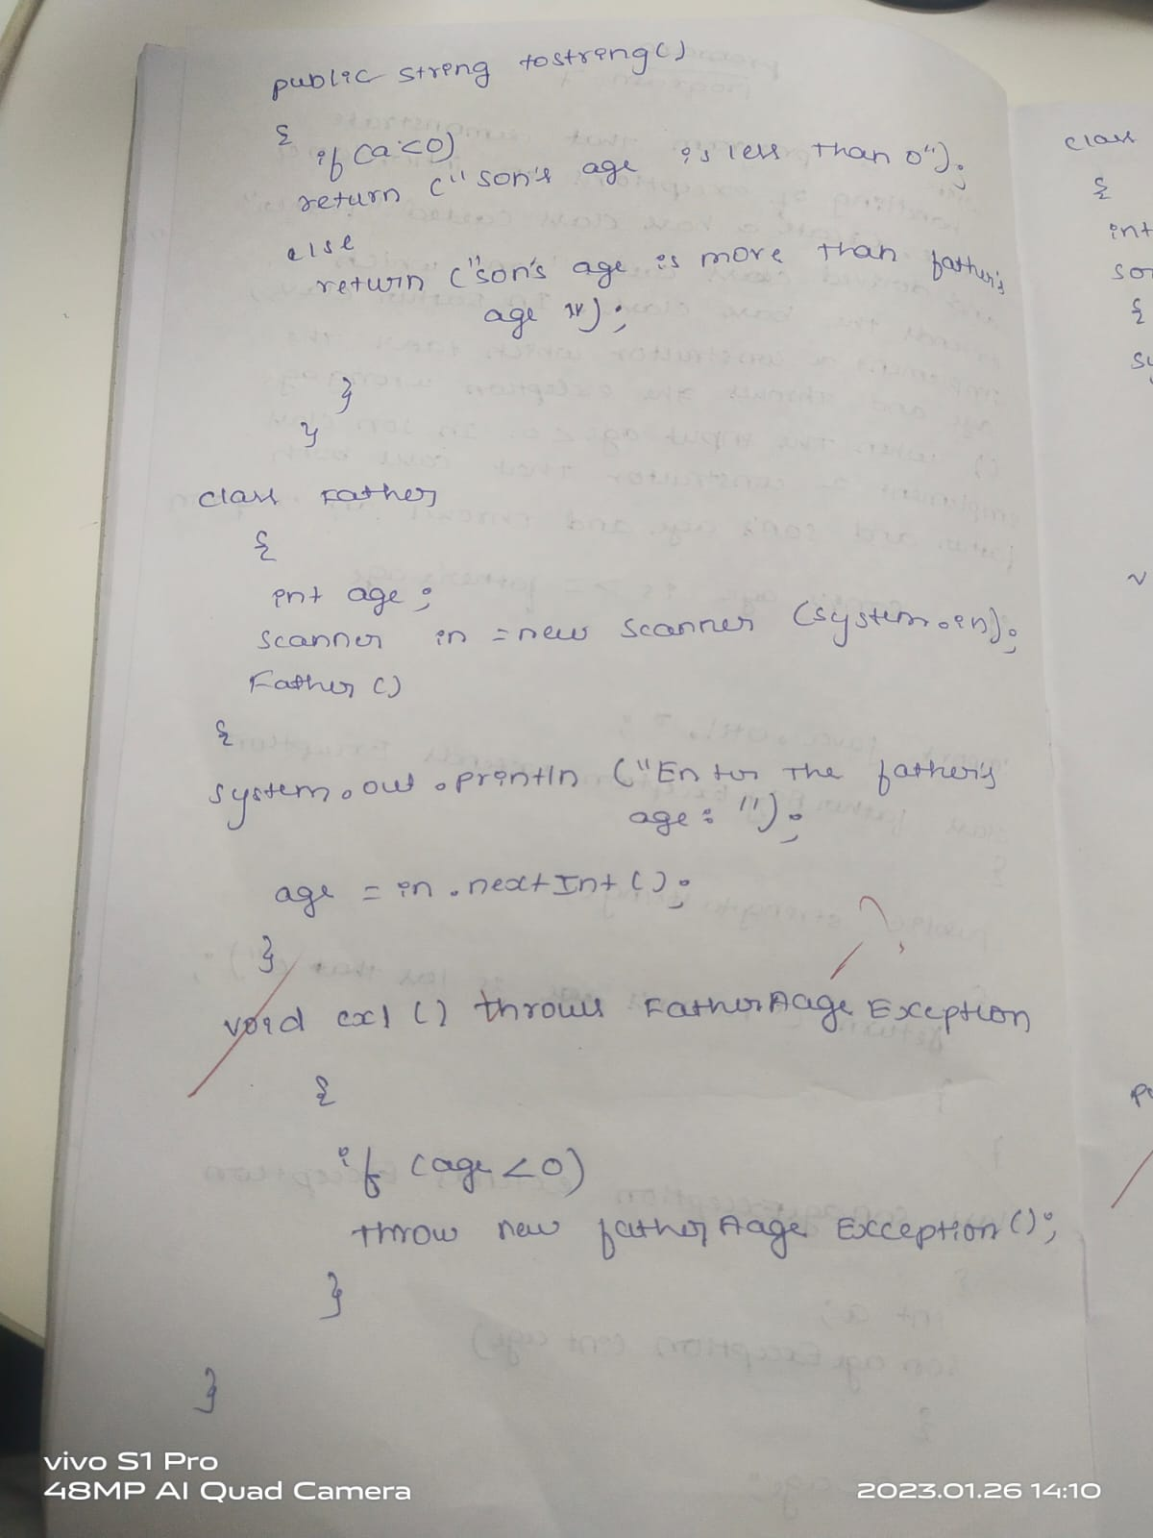

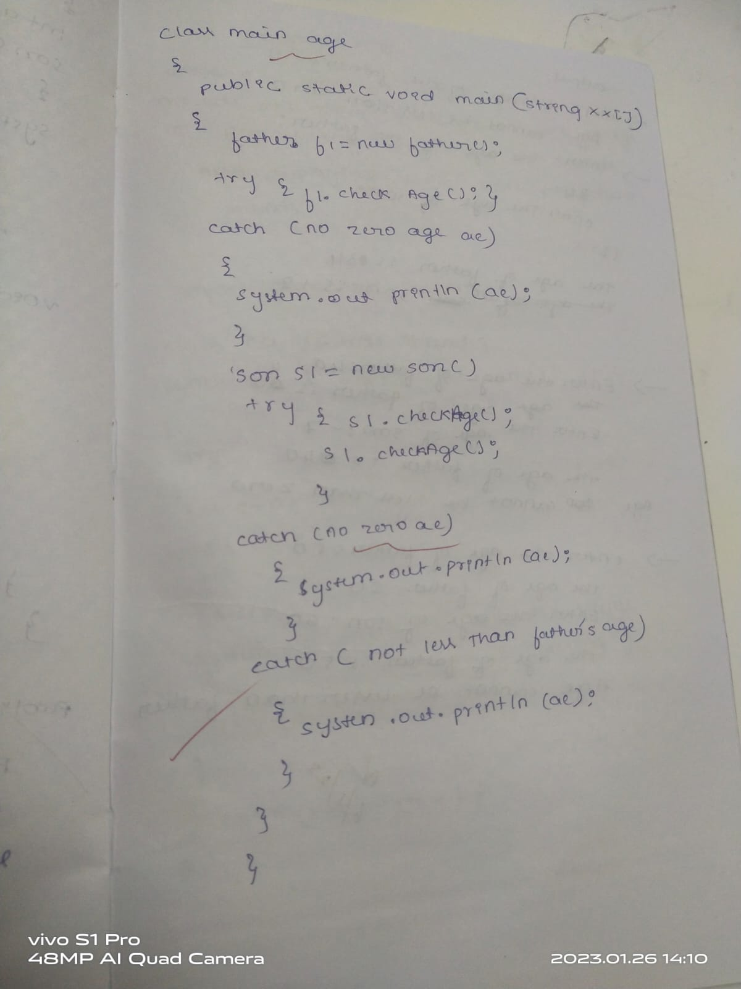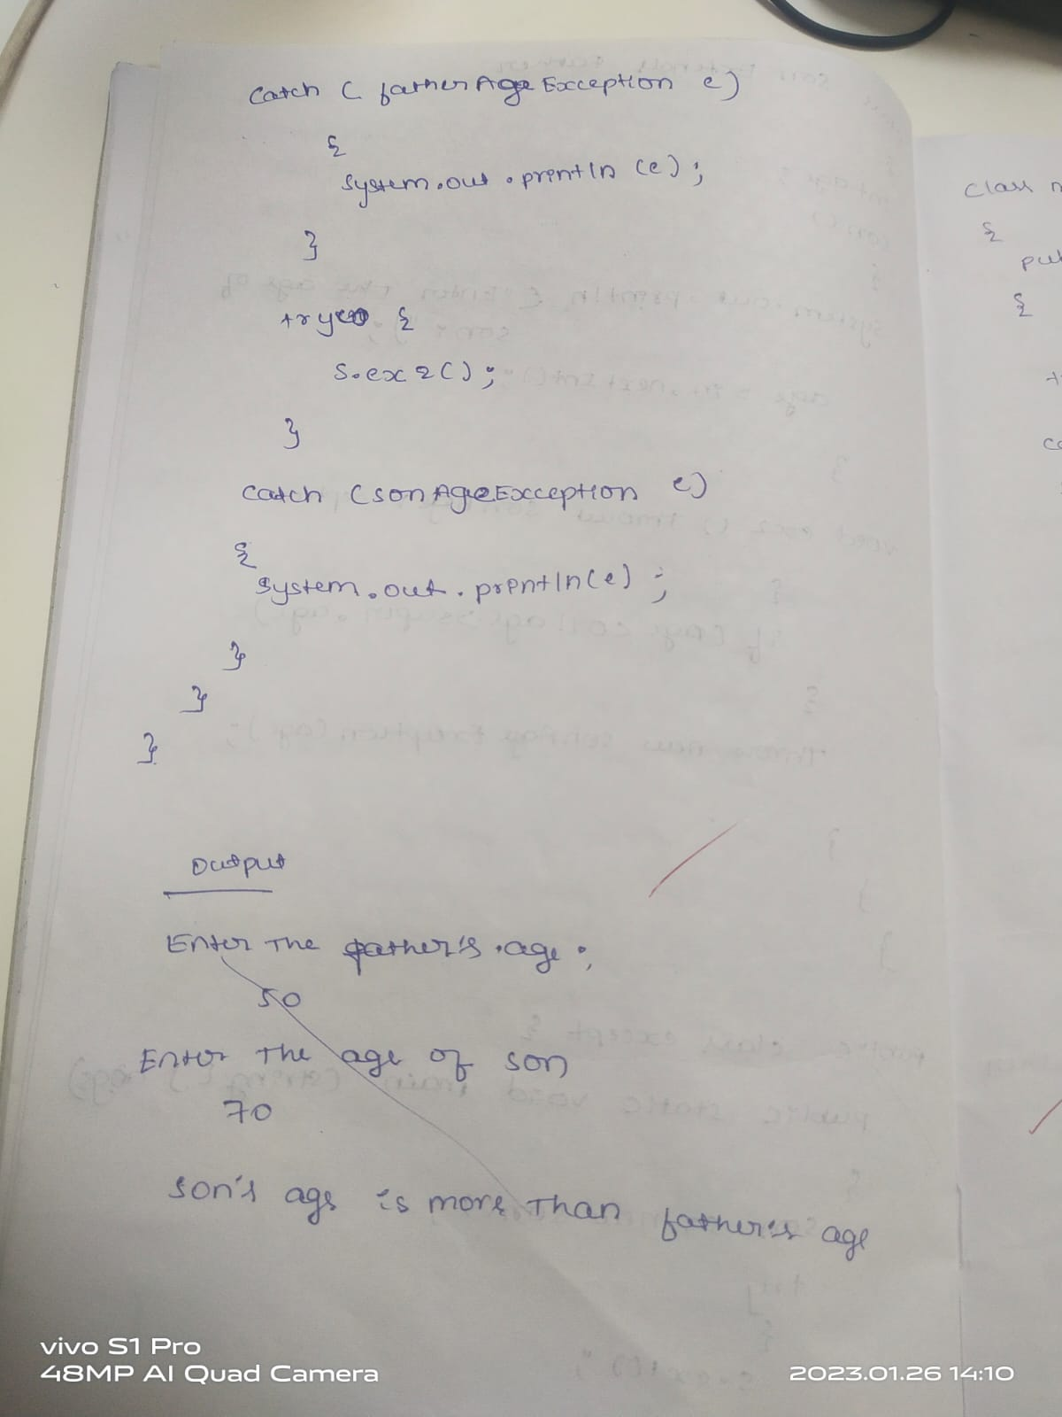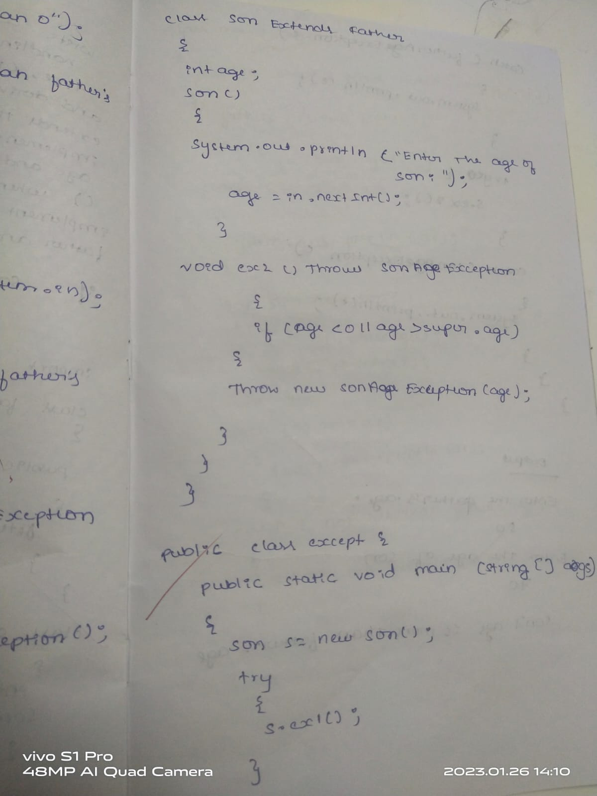

7.Write a  
program which creates two threads, one thread displaying “BMS College of  
Engineering” once every ten seconds and another displaying “CSE” once every two  
seconds.

import java.util.Scanner;

class Cse extends Thread {

synchronized public void run() {

try {

int i=0;

while (i<5) {

sleep(2000);

System.out.println("Computer science engineering ");

i++;

}

} catch (Exception e) {

}

}

}

class Bms extends Thread {

synchronized public void run() {

try {

int i=0;

while (i<5) {

sleep(10000);

System.out.println("BMS college of engineering ");

i++;

}

} catch (Exception e) {

}

}

}

class Main{

public static void main(String args[]) {

Bms t1 = new Bms();

Cse t2 = new Cse();

t1.start();

t2.start();

}

}

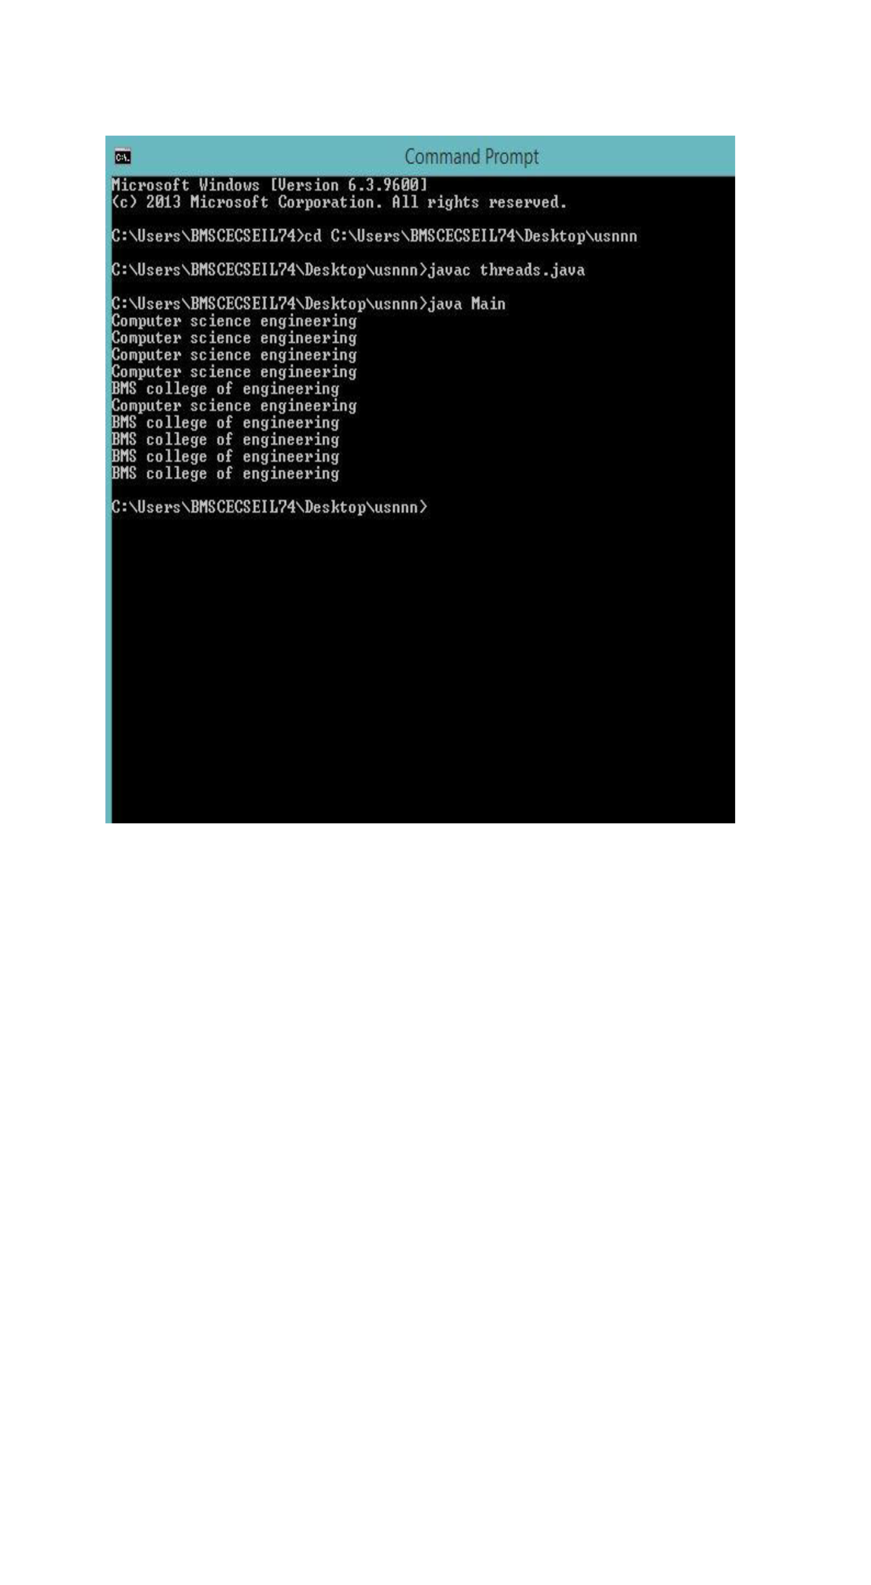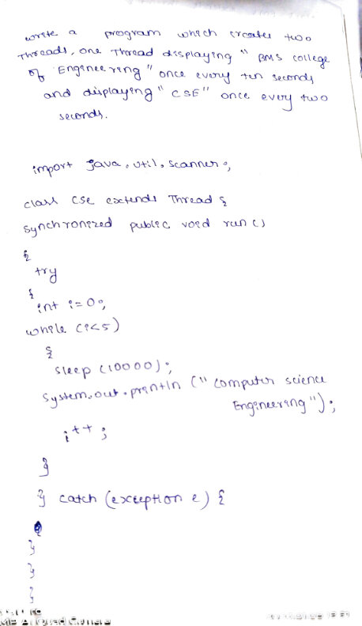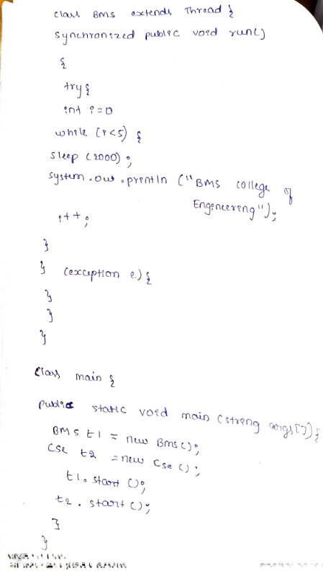

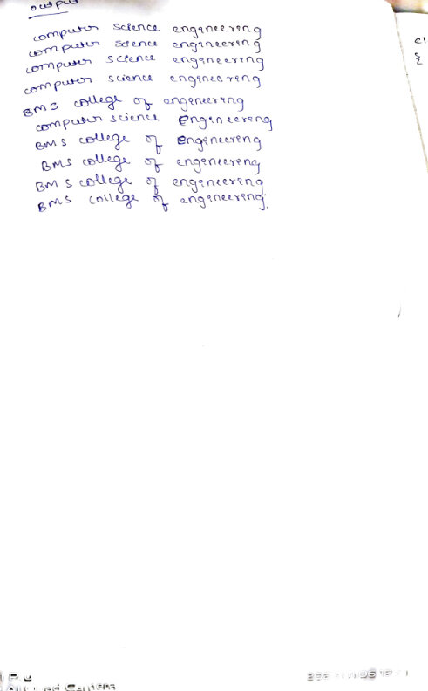 8.Create a package **CIE** which has two classes- **Student** and **Internals- a subclass of Student**. The class **Student** has members like usn, name, sem. The class **internals** has an array that stores the internal marks scored in five courses of the current semester of the student.   
Create another package **SEE** which has the class **External** which is a derived class of **Internals**. This class has an array that stores the **SEE** marks scored in five courses of the current semester of the student. Import the two packages in a file that declares the final marks of n students in all five courses.

package CIE;

import java.util.*;

public class internals extends CIE.student {

Scanner sc=new Scanner(System.in);

public int ciem[]=new int[5];

public void accept(){

int i;

for(i=0;i<5;i++)

{ System.out.println("Enter CIE marks of subject "+(i+1));

ciem[i]=sc.nextInt();

}

}

}

package SEE;

import CIE.*;

import java.util.*;

public class externals extends CIE.student{

Scanner sc=new Scanner(System.in);

public int seem[]=new int[5];

public void accept(){

for(int i=0;i<5;i++)

{

System.out.println("Enter SEE marks of subject "+(i+1));

seem[i]=sc.nextInt();

}

}

}

package CIE;

import java.util.*;

public class student{

Scanner sc=new Scanner(System.in);

public String usn,name;

public int sem;

public void accept(){

System.out.println("Enter USN, Name and Current semester: ");

usn=sc.nextLine();

name=sc.nextLine();

sem=sc.nextInt();

}

public void display(){

System.out.println("\nStudent Details");

System.out.println("Name: "+name);

System.out.println("USN: "+usn);

System.out.println("Semester: "+sem);

}

}

import CIE.*;

import SEE.*;

import java.util.*;

class total{

public static void main(String args[]) {

int i,j,n;

Scanner sc=new Scanner(System.in);

int total[]=new int[5];

System.out.println("Enter number of students: ");

n=sc.nextInt();

CIE.student s[]=new CIE.student[n];

CIE.internals ci[]=new CIE.internals[n];

SEE.externals se[]=new SEE.externals[n];

for(i=0;i<n;i++)

{

System.out.println("\nEnter student "+(i+1)+" details");

s[i]=new CIE.student();

s[i].accept();

ci[i]=new CIE.internals();

ci[i].accept();

se[i]=new SEE.externals();

se[i].accept();

}

for(i=0;i<n;i++)

{

System.out.println("\nDetails of student "+(i+1));

s[i].display();

for(j=0;j<5;j++)

{

total[j]=ci[i].ciem[j]+se[i].seem[j];

System.out.println("Total marks in subject "+(j+1)+": "+total[j]);

}

System.out.println();

}

}

}

